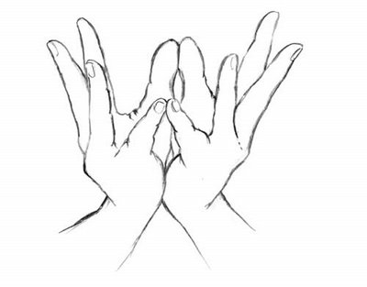

Padma Mudra or Lotus flower Peace and compassion
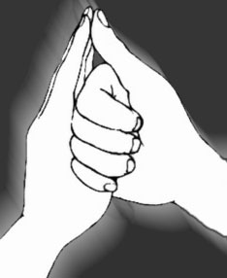

Shankh Mudra or Shell (counch)
Safety, calming effect, clarity of speech
Picture from: elrincondelsadhu.blogspot.com
Designed by Pam Smith Paquette
www.yogawithgrace.net

Padma Mudra or Lotus flower Peace and compassion

Shankh Mudra or Shell (counch)
Safety, calming effect, clarity of speech
Picture from: elrincondelsadhu.blogspot.com
Designed by Pam Smith Paquette
www.yogawithgrace.net

